Polynomial Regression

In statistics, polynomial regression is a form of regression analysis in which the relationship between the independent variable x and the dependent variable y is modelled as an nth degree polynomial in x. Polynomial regression fits a nonlinear relationship between the value of x and the corresponding conditional mean of y, denoted E(y |x). Although polynomial regression fits a nonlinear model to the data, as a statistical estimation problem it is linear, in the sense that the regression function E(y | x) is linear in the unknown parameters that are estimated from the data. For this reason, polynomial regression is considered to be a special case of multiple linear regression.
The explanatory (independent) variables resulting from the polynomial expansion of the "baseline" variables are known as higher-degree terms. Such variables are also used in classification settings
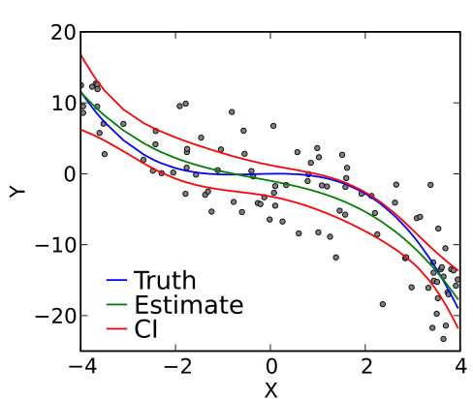
Definition and example:

The goal of regression analysis is to model the expected value of a dependent variable y in terms of the value of an independent variable (or vector of independent variables) x. In simple linear regression, the model

Y = B₀ + B₁x + ε

is used, where ε is an unobserved random error with mean zero conditioned on a scalar variable x. In this model, for each unit increase in the value of x, the conditional expectation of y increases by β1 units.
In many settings, such a linear relationship may not hold. For example, if we are modeling the yield of a chemical synthesis in terms of the temperature at which the synthesis takes place, we may find that the yield improves by increasing amounts for each unit increase in temperature. In this case, we might propose a quadratic model of the form

Y = B₀ + B₁x + B₂x² + ε

In this model, when the temperature is increased from x to x + 1 units, the expected yield changes by (This can be seen by replacing x in this equation with x+1 and subtracting the equation in x from the equation in x+1.) For infinitesimal changes in x, the effect on y is given by the total derivative with respect to x: The fact that the change in yield depends on x is what makes the relationship between x and y nonlinear even though the model is linear in the parameters to be estimated.

In general, we can model the expected value of y as an nth degree polynomial, yielding the general polynomial regression model

Y = B₀ + B₁x + B₂x² + B₃x³ + … +B_{n}x^{n} + ε

Conveniently, these models are all linear from the point of view of estimation, since the regression function is linear in terms of the unknown parameters β0, β1, .... Therefore, for least squares analysis, the computational and inferential problems of polynomial regression can be completely addressed using the techniques of multiple regression. This is done by treating x, x2, ... as being distinct independent variables in a multiple regression model.

Matrix form and calculations of estimates

The polynomial regression model

Y_{i} = B₀ + B₁x_{i} + B₂x_{i}² + B₃x_{i}³ + … + B_{n}x_{i}^{n} + ε_{i}

(i = 1,2,3..n)

can be expressed in matrix form in terms of a design matrix , a response vector , a parameter vector , and a vector of random errors. The i-th row of and will contain the x and y value for the i-th data sample. Then the model can be written as a system of linear equations:

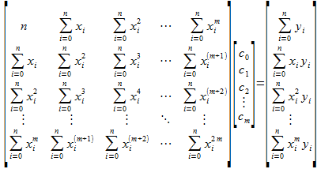

My Implementation

There are two types of regression in my project:

1) Linear regression (a special case of polynomial regression)

2) Polynomial regression

Linear regression was implemented separately because it is calculated by formulas much faster than polynomial regression through determinants.

The equation has the form Y= a + bX, where Y is the dependent variable (that’s the variable that goes on the Y axis), X is the independent variable (i.e. it is plotted on the X axis), b is the slope of the line and a is the y-intercept.

How find linear regression coefficients:
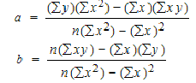

In Linear regression was easy to implement because we just runs through array and find sums.

Main functions in Linear regression was:

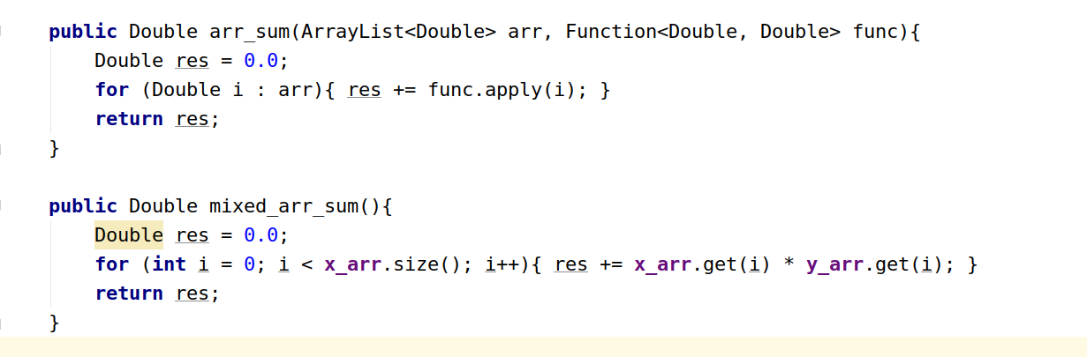
And after this we just implement formulas by using this functions:

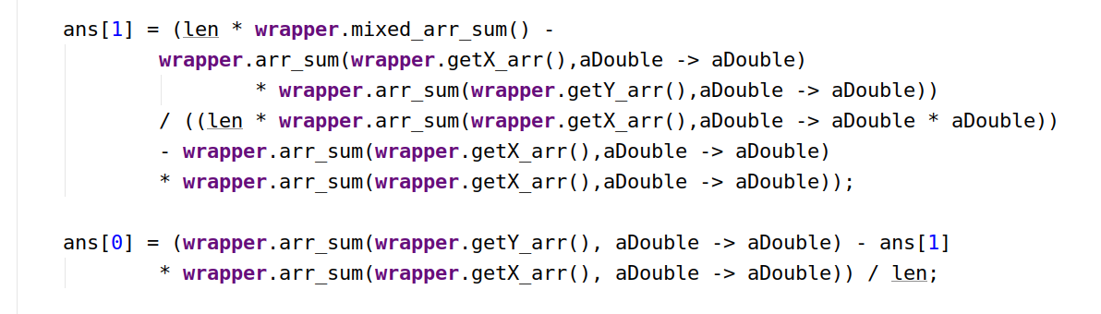

Finding Polynomial regression

Polynomial regression has four main parts:

1) Main equation for predicted Y

2) Big matrix for X values

3) Coefficients matrix

4) Mixed matrix for X and Y values

For calculating regression we use Cramer`s rule for finding coefficients

Steps:

1) Find big matrix determinant

2) Calculate each coefficient by Cramer`s rule

Important term for finding regression is calculating determinant. I implement this by using recursion every time chop array and calculate it by using brute force algorithm
